Quantifying surface water-groundwater exchange using temperature profile inverse modelling in a riparian wetland

Jack Lange

Submitted under the supervision of Crystal Ng to the University Honors Program at the University of Minnesota-Twin Cities in partial fulfillment of the requirements for the degree of Bachelor Science, *summa cum laude* in Earth Sciences.

[Date]

Abstract

Second Creek is wild rice stream located on the Iron Range in northeast Minnesota that has been impacted by mining pollution. In order to understand how mining-derived sulfate affects biogeochemical cycling at Second Creek, surface water-ground water exchange must be quantified, because it controls geochemical gradients in the sediment. We employed inverse modeling of temperature profiles to estimate hyporheic flux at the site. Temperature profile methods have been most widely applied in streambeds with sediments that are sand-size and greater and support relatively high flux magnitudes. In contrast, the Second Creek study site is a riparian wetland where low hyporheic flux is expected due to high organic content in the sediments.. Streambed temperature profiles were measured continuously over the summer of 2016 at three locations across a transect spanning from the main stream channel to the flanking wetland area.  The data were collected using low-cost, open-source vertical temperature profilers and “ALog” data loggers. The USGS model 1DTempPro was applied to the temperature data, along with co-located head data, at each location to estimate hydraulic conductivity across the transect. The sediment thermal parameters used in the model were constrained based on the sediment bulk density, which is strongly controlled by organic content. The estimated hydraulic conductivity values were applied to the measured head gradients to generate time series of hyporheic flux time across the transect over the summer. Results showed spatial variability in both hydraulic properties and hyporheic flux. Across the transect, flux was upward toward the surface water for nearly the entire summer, though the magnitude of the flux varied dynamically in response to variable weather conditions and one flux reversal occurred following a strong late-summer storm event.

Acknowledgments

Table of Contents

Introduction

The chemical conditions in the porewater of a wetland influence plants rooted in the hyporheic zone. In wetland settings, groundwater – surface water exchange drives biogeochemical cycling in the hyporheic zone [] . The groundwater-surface water exchange must be quantified in order to understand biogeochemical cycling in the porewater. Biogeochemical cycling is important to understand because the porewater conditions directly affect the biota that live in the streambed, including aquatic plants such as wild rice. Wild rice is sensitive to sulfur concentrations in the water. Sulfur present in the water comes from mining pollution sulfate that is reduced in situ. This study focuses on using the Inverse Temperature profiling method to constrain groundwater – surface water exchange at a wetland site in northern Minnesota. 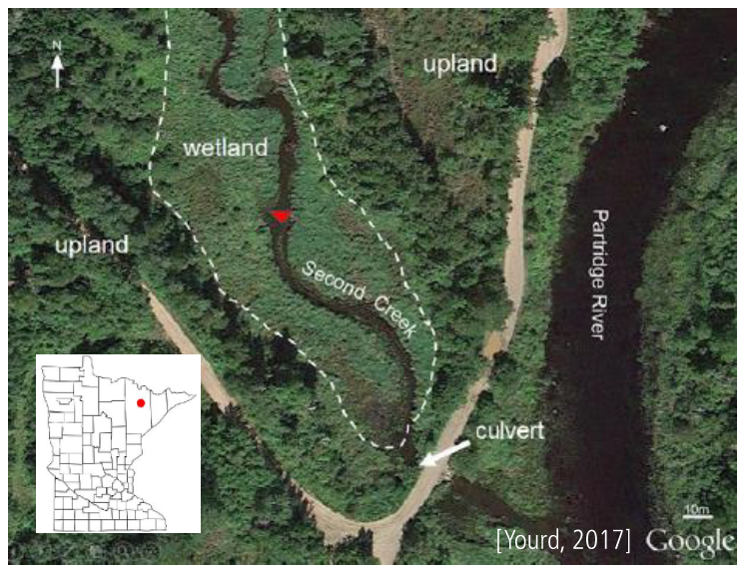

Heat is a tracer that can be sued to quantify groundwater flux. Diurnal lvariability.(see usgs 2013) The inverse temperature profile model method is a method of estimating hydraulic parameters by matching a synthetic streambed temperature profile with an observed temperature profile. The method was first developed [ ] and has seen numerous iterations, spinoffs and improvments [] since.

This work fits in to a broader biogeochemical study of the site. The study site is a wild rice(manoomin?) stream located on Minnesota’s iron range. More information on the broader scope of the study can be found at []. The results of this work have been used with reactive transport modeling to investigate the influence of hyporheic flux on biogeochemical cycling at Second Creek. [ng presentation ]

Methods

Darcy’s law describes the movement of fluid through a porous media. It is presented here

(explain variables). The quantity of interest in this study is qz, the vertical hydraulic flux. The head gradient, dh/hz, is calculated from the piezometer and stream gauge measurments. As is the classic problem in hydrogeology, the hydraulic conductivity, K, is the most challenging parameter to pin down. The inverse temperature profiling method is employed to estimate K.

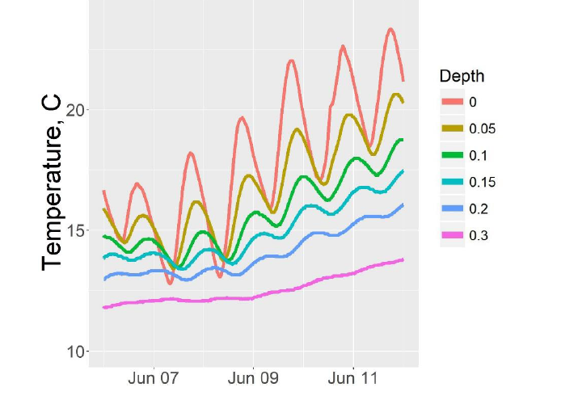

The Inverse Temperature Profile Modeling method uses temperature as a tracer for streambed flux. 1D heat transport in the streambed is predicted by the heat-transport equation. The heat transport equation can be used to generate a synthetic temperature profile, which is adjusted by adjusting hydraulic conductivity to amtch the observed prodfile. The forward model uses the top and bottom temperature probes , and a frwards difference scheme to generate the synthetic profile. Then the parameters are adjusted (K) to match the observed and estimated profiles. More detailed explanation of the model, and previous temperature profile modelling work can be found in (2008), Anderson (2005), and Constantz and Stonestrom (2003).”(usgs 2013)

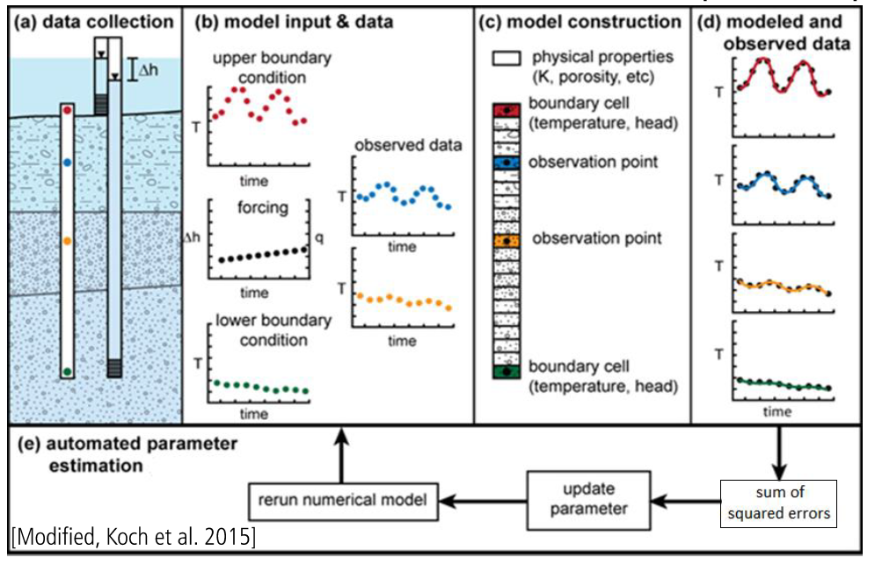

General overview similar to intro

Talk about the usgs model, what makes It unique nad useful (PEST)

Data Collection and Wrangling

To inform the inverse model, temperature and head data ta was collected during the summer of 2016. Tem groundwater.

“The temperature probes were constructed using 1-inch diameter PVC tubing

with a series of 6thermistors affixed with epoxy. The probes were inserted into the

stream or wetland sediment such that the top thermistor was approximately at the

sediment-water interface, and the bottom thermistor was located at approximately 30-40

cm depth below the sediment-water interface, with most sensors clustered within the top

10 cm, which corresponds to the wild rice root zone. “(yourd)Temperature readings were logged

at 10 -15 minute intervals to capture diurnal and seasonal variability at the site. TPB and TPC collected data from June to August. TPA collected data from June to October.

head data was collected using piezomnrs (pressure trasducers) located (figure to show piezometers), additionally atmospheric pressure data was provided \_\_\_\_ and precipitation data was acquired from the Embarrass MN eather station.

Temperature data was collected at three locations along a transect spanning the streambed and wetland. The location of each temperature probe is show in figure\_\_

Sample temperature profiles and head data is available in . The data was collected using low cost, open source Data Loggers developed by Andrew WIckert and Chad Sandell () . More information on the data loggers can be found at:

Gaps in the data existed due to \_\_\_ and \_\_\_ . Additionallym, the stream gauge was moved during the summer . The true elevation of the stream gauge was triangulated based on surveyed elevation of pressure transducers and stream head.precip data from the embarrass mn weather station, 10 miles north

Thermal parameter estimation

These model inputs had to be estimated by hand, 1D temp can only estimate one parameter at a time

The inverse temperature profile modelling approach has primarily been applied in settings where the thermal parameters are relatively insensitive and invariatnt, for example rocky and sandy stream beds wehre the theremal parameters can be roughly estimated as siliclastic miunerals. At second Creek the streambed is composed of a mixture of siliclastic and heavily organic matter. Furthermore, the sediment at Second Creek is extremely heterogeneous, as show in the soil samples in figure \_\_.

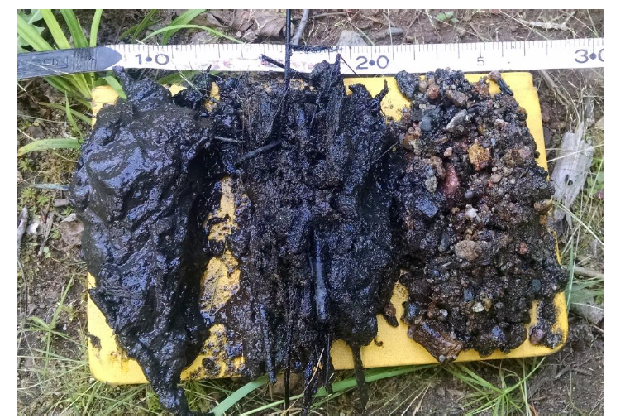

Yourd 2017

In order to make a reasonable estimation about the thermal parameters, some simplifying assumptions were required. The first simplifyinfg assumption was that the sediment was made up of two endmembers, siliclastic sediment and soil organic matter. The second simplifying assumption is that the streambed is heterogeneous. Both of these assumptions will be justified during model sensitivity analysis. With the first simplifying assumption, the fraction of siliclastic and SOM in the soil can be calculated. Using a dry bulk density measured in (mybro), (also porosity)and the literature values for siliclastic sediment and som density (farouki),a linear combination of each endmember gives the appropriate fgraction of each in the soil

Linear sum equation.

Using the fraction of SOM and siliclastic, the thermal properties of the streambedk can be estimated by two methods in Farouki

Equation

Each of these methods gives an upper and lower limit on the thermal properties (conductivity and saturated heat capacity. The validity of these will be testd in the results section

The last parameter to estimate is dispersivity. This parameter depends on the scale of the problem, and the qz. AS such it is bes t estimated by sensitivity analysis

stimating the thermal parameters required estimating the fraction of silicate to SOM and The thermal parameters of each. Sensitivity analysis was used to test the validity of the assumptions that were made.

-note that there is uncertainty here

So, with the model informed and data in place here are the results

Results and Conclusions

Start with the plot of flux over the summer

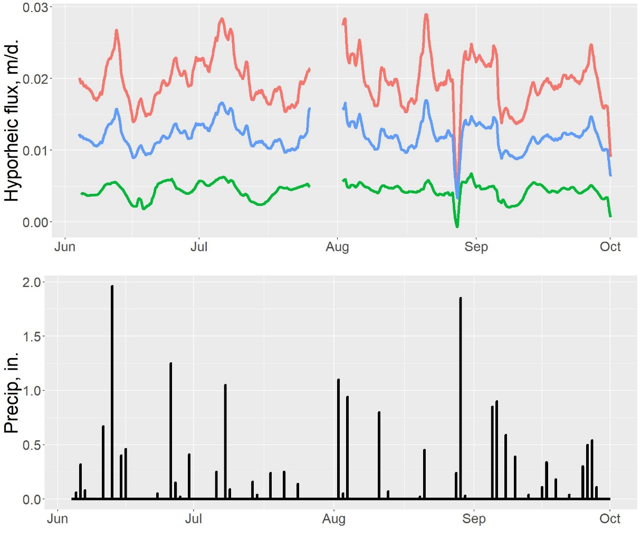

Sensitivity analysis

To evaluate the quality of the model results and dependencies of the hand estimated parameters… The inverse model was run over the range of parametersestimated earlier. The inverse model was run as each parameter was varied over its range,while the rest of the parameters were held constant at a middling value in their range. The resulting value of K for each of these model runs is presented in figure (). The goodness of fit between the model’s final synthetic profile and theobserved temperature profile is qualitatively demonstrated by the size of each point

C:\SecondCreekGit\Presentations and figures\North Central GSA poster\q_smoothed.tif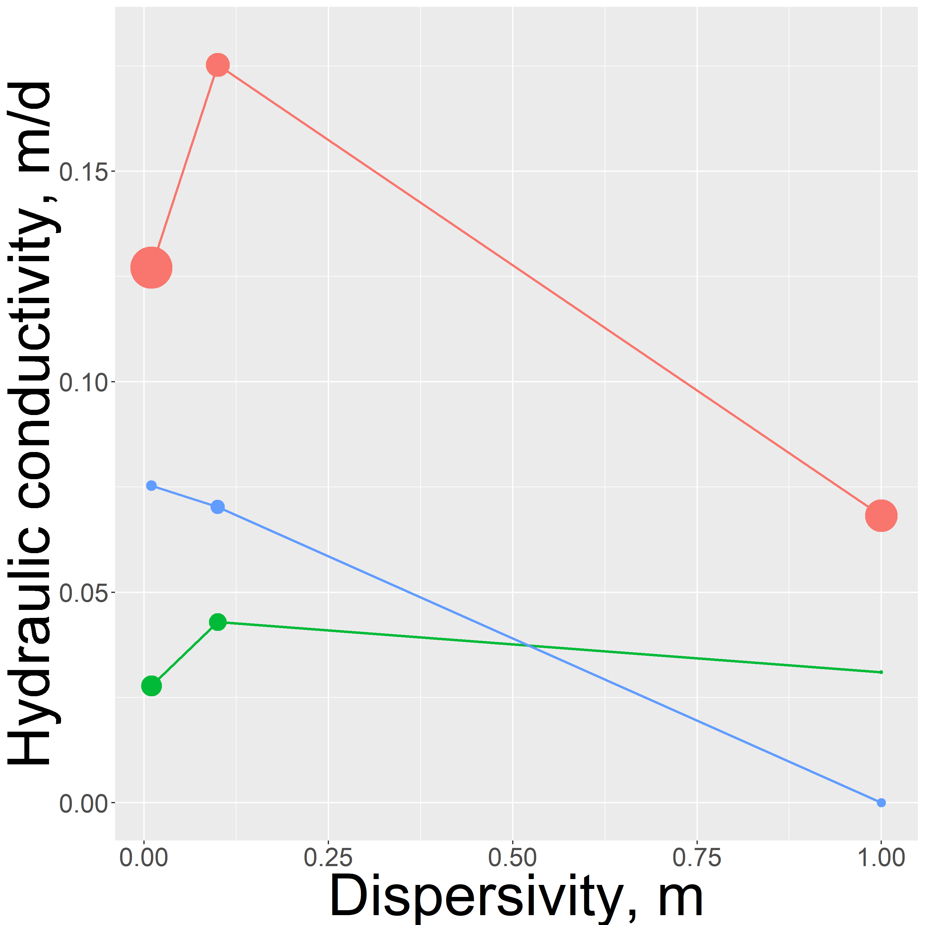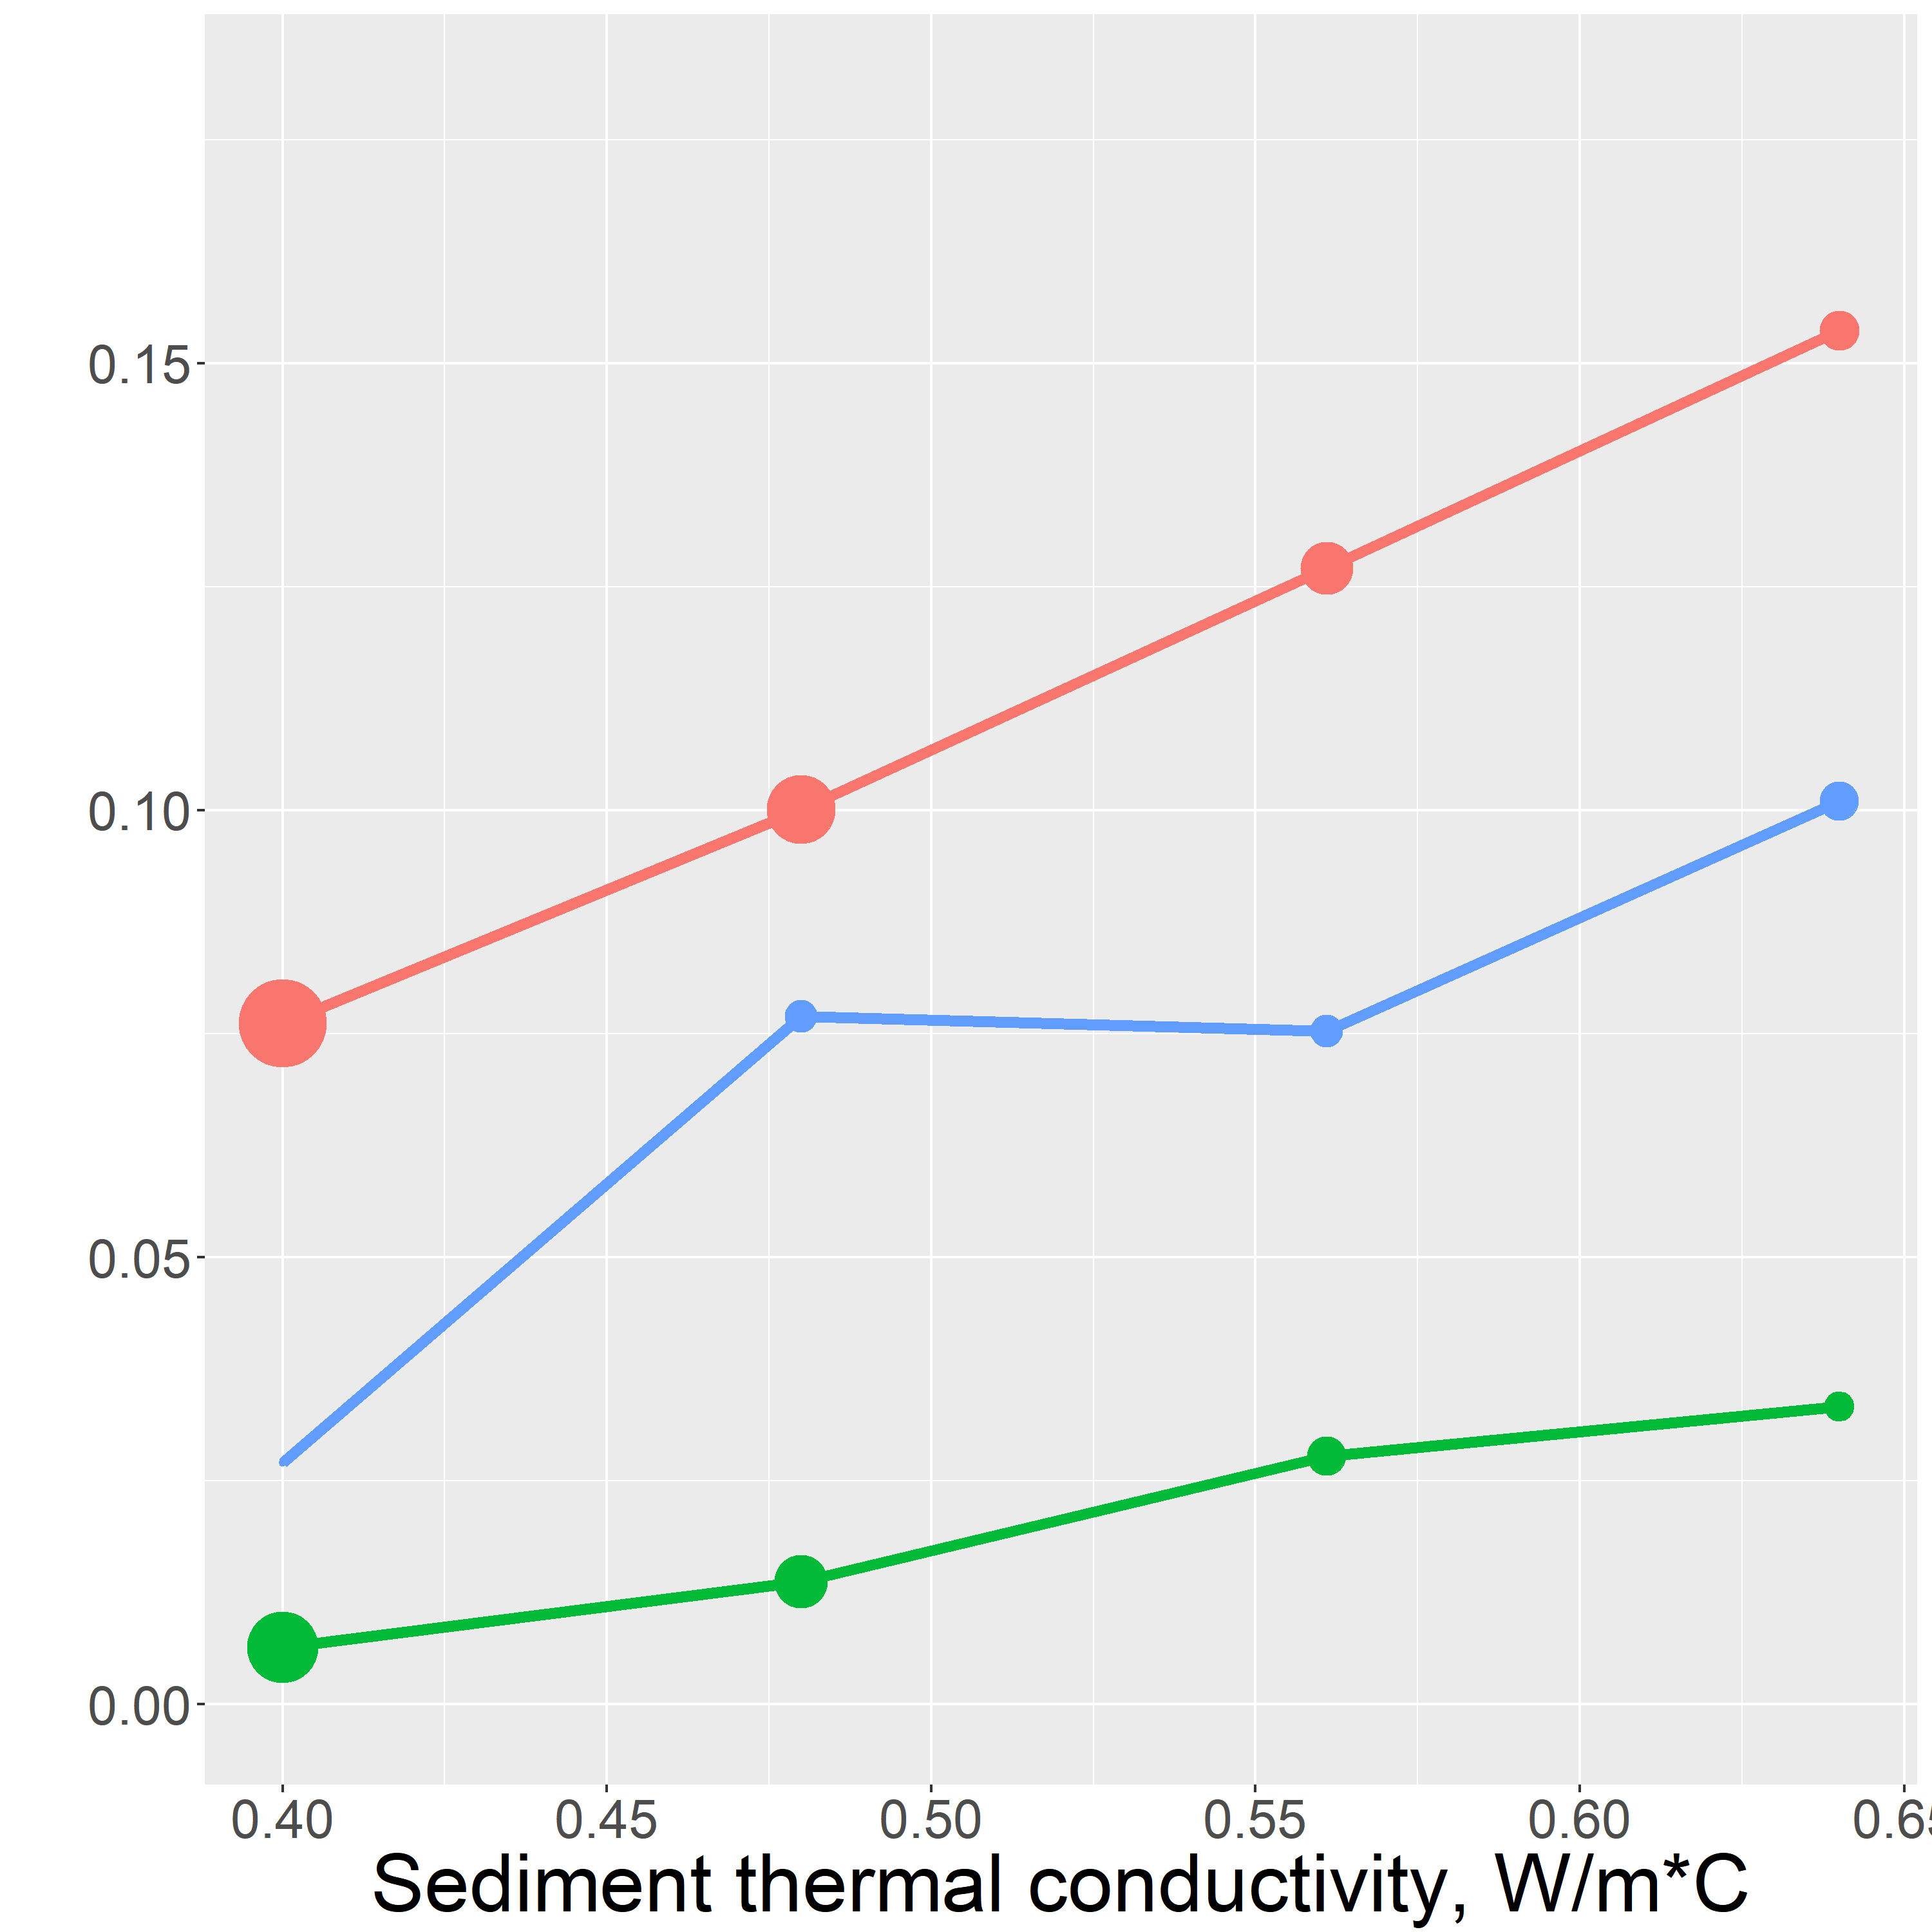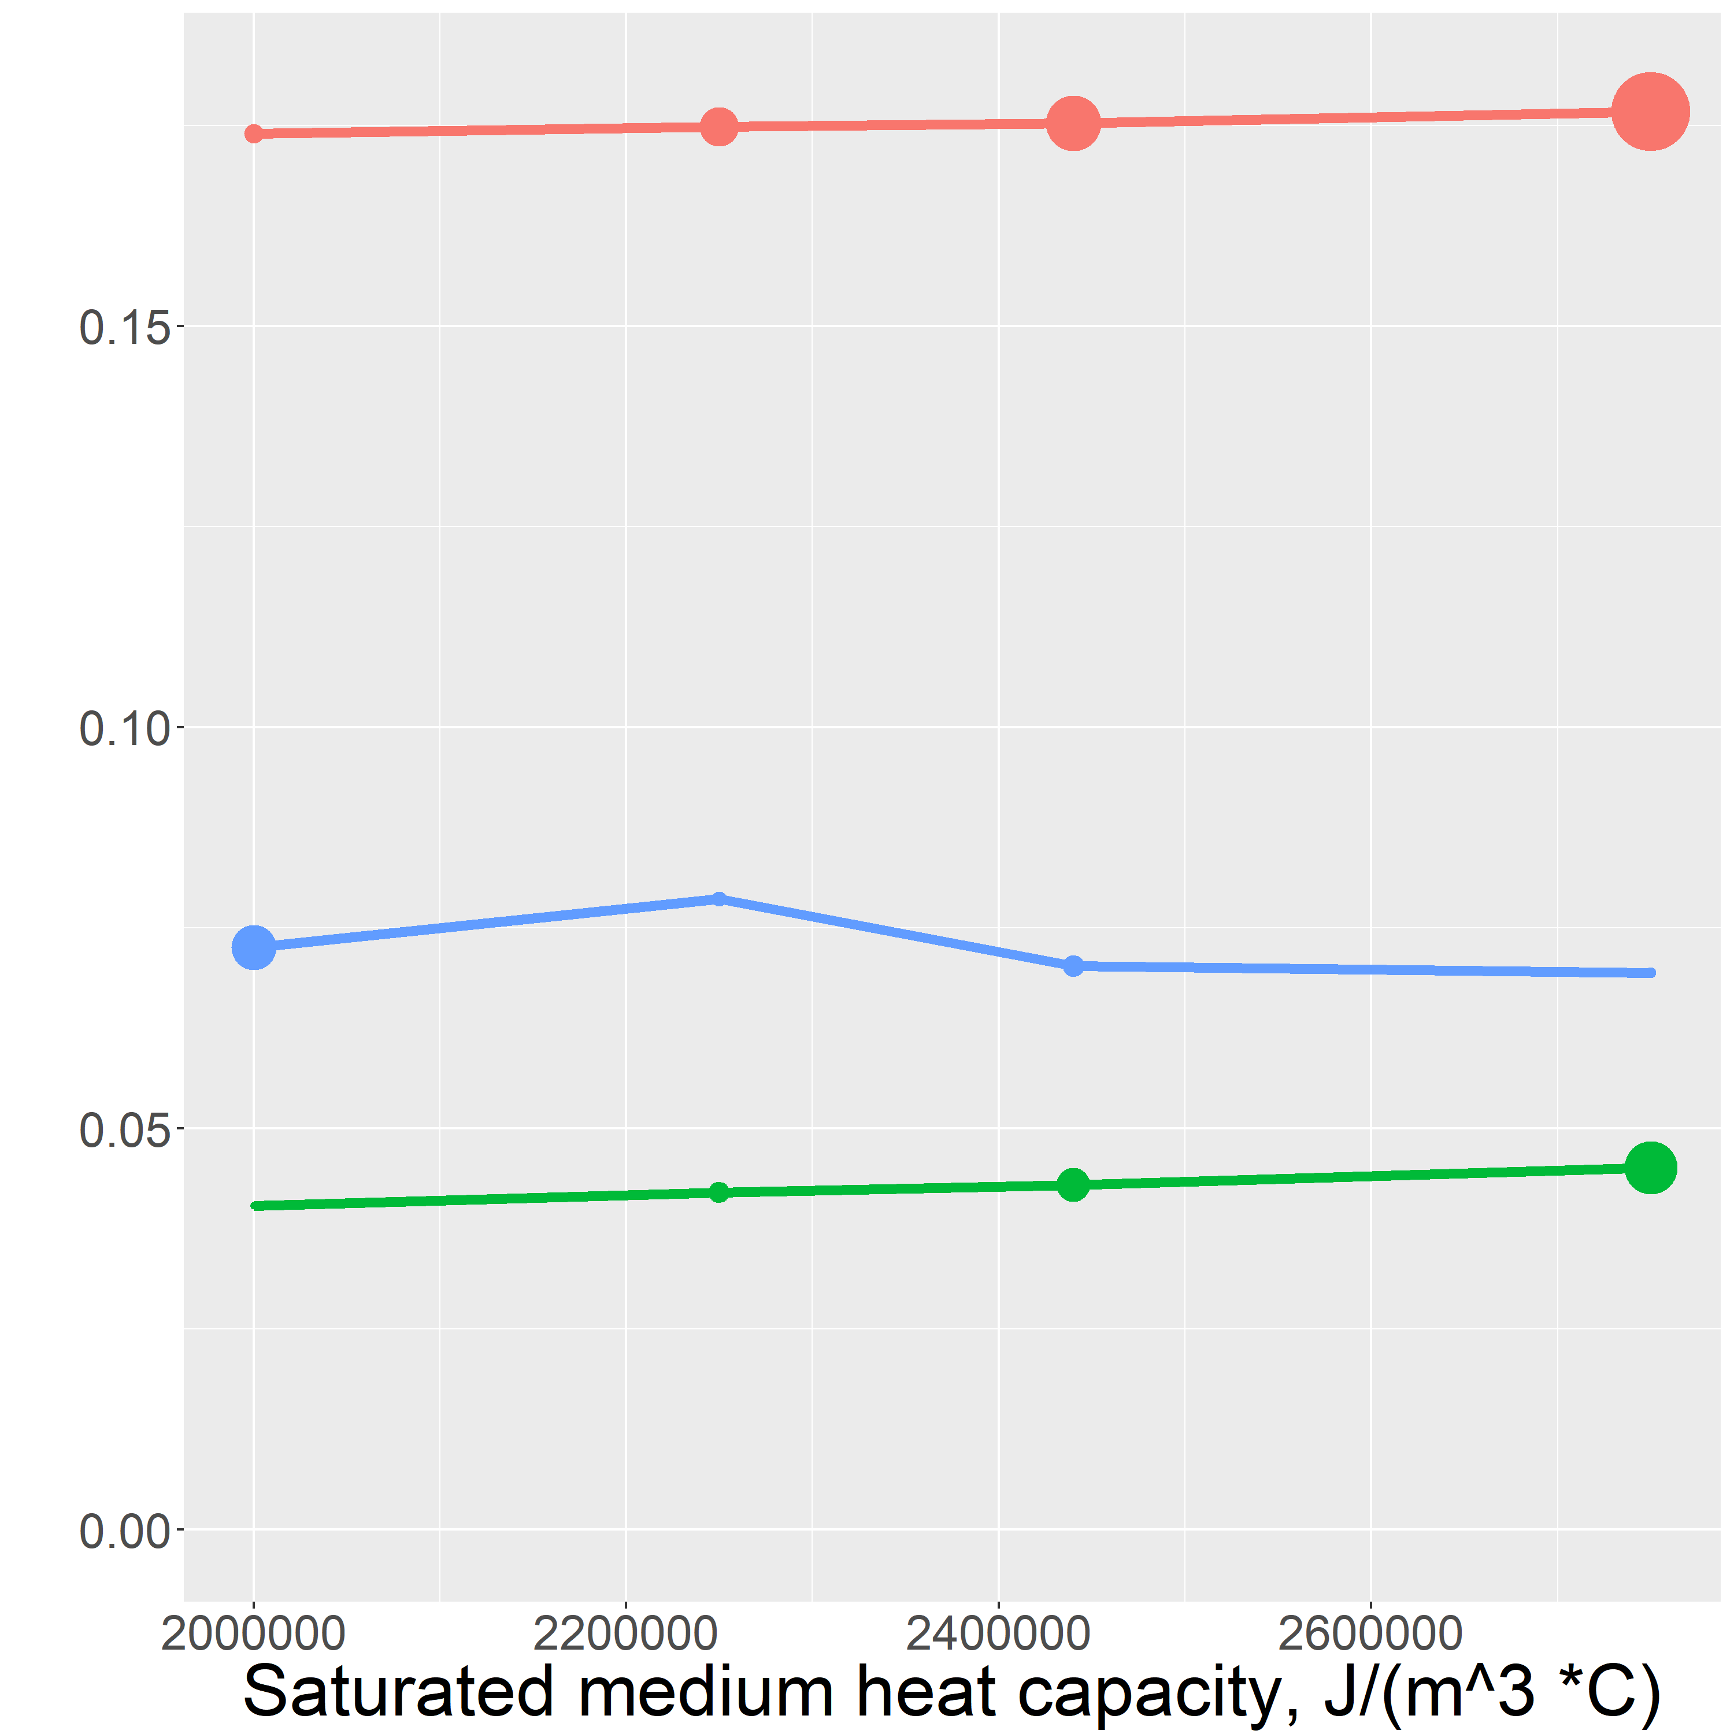

The goodness of fit between the model’s final synthetic profile and the observed temperature profile is qualitatively demonstrated by the size of each point. (add a model failure arrow)

Dispersity sensitivitvity

Unlike the other hand estimated parameters, the inverse model is not linearly sensitive to the value of dispersity. This nonlinearity is caused by the dependence of dispersivity on flux magnitude,

Alpha = vD

Dispersitivity can vary by orders of magniture depending on the scale of the are a considered. These made dispersivity the hardes parameter to hand estimate. Using a value of 0.1 m gave the best quality of fit for the inverse model.

Thermal conductivity

The dependency of the inverse model results on thermal conductivity is a linearly increase over the range of values.

Saturated heat capacity

The most obvious conclusion from this analysis is that the saturated heat capacity is the least sensitive paramaeter of the hand estimated parameters. The saturated heat capacity calue that gave the best fit at all of the temperature probes is 2.25 \* 10^6 J/(m^3 \* C) which is the saturated heat capacity of a \_% silicate \_% organic matter \_% water mixture , consistent with the conditions at the site.

The final parameter values are show in table \_

Generally, the variation in results is low elative to the possible variability of K, furthermore it is good that the general trend is maintained

C:\SecondCreekGit\Presentations and figures\North Central GSA poster\q_smoothed.tifThese values were used to produce figure () which shows flux from darcy’s law at each location over the summer 

(include note about what diresction is up)

The highest hydraulic conductivity and flux occur in the west wetland, followed by the stream center and the west stream channel. This is counterintuitive, as we originally expected the west wetland to have the smallest flux. A possible explanation is the extreme heterogeneity of the sediment at the site. The generalization of ones et of thermal parameters for all of the temperature probes does not capture the sites heterogeneity. Furthermore, inthis study the temperature probes and piezometers were not perfectly collocated. However, I think that the greatest source of this discrepancy ould be that the non purely vertical flow, perhaps water is flowing more to the stream? (talk to crystal)

The direction of vertical flux across the transect is upwards for the entire summer except for one brief flux reversal in late August. The magnitude of vertical hydraulic flux over the summer is variable., The flux magnitude appears to be linked with precipitation. Major changes in flux magnitude occur following large rain events. Sometimes these rain events incresase the upward sflux magnitude, indicating that a the rainfall initiates a baseflow event. In other cases, rain events are followed by decreased upwardsflux, or even downwards flux, indicating that the rainfall ranoff into the surface water quickly. It is worth noting that the precipitation data was collected from a weather station that is 10 miles north of the study site, so it is possible that they do not experience the same meteorological conditions. (this is really far away, just think about how variable precip can be in the twin cities), so the sterams response to the storms could be related to the proximity of the storm to the stream. For example, a distant storm would be more likely to trigger a large, prolonged baseflow event, and a storm that occurs on second creek could cause a rapid rise I nsurface water levels, resulting in an immediate decrease in upwards flux, and in the case of an extreme storm, downwards flux.

Generally upwards flux, controlled precipitation

The results could be expanded and improved by doing unique sediment parameter calibration for each temperature probe. This includes, porosity as well as thermal parameters. This could be achieved by careful sediment sampling and analysis in the field, or by employing a multiple parameter estimation routine such as PEST(citation).

This USGS software has two citations associated with it.

1. The report citation is for the original report or article documenting the underlying theory, methods, instructions, and (or) applications at the time the initial version of the software was released. This digital object identifier (DOI) is for the report.
2. The software release citation is for the software/code itself (now referred to by USGS as a "Software Release") and references a specific version of the code and associated release date. This DOI links to the code.
3. **Farouki, O., 1961.** *Thermal properties of soils*. United States Army Corps of Engineers Cold Regions Research and Engineering Laboratory.; **Hayashi, M. & Rosenberry, D.O., 2002.** Effects of Groundwater Exchange on the Hydrology and Ecology on Surface Water. *Groundwater*.; **Healy, R.W., and A.D. Ronan. 1996.** Documentation of computer program VS2DH for simulation of energy transport in variably saturated porous media – modification of the U.S. Geological Survey’s computer program VS2DT. *U.S. Geological Survey Water-Resources Investigations Report*.; **Koch et al. 2015.,** 1DTempPro V2: New Features for Inferring Groundwater/Surface-Water Exchange*, Groundwater*.; **Kurtz, A.M. et al., 2007.** The importance of subsurface geology for water source and vegetation communities in Cherokee Marsh, Wisconsin. *Wetlands*.; **Mybro, A., 2013**. Wild Rice Sulfate Standard Field Surveys 2011, 2012, 2013: Final Report. *University of Minnesota*.; **Yourd, A., 2017.** *Using reactive transport modeling to link hydrologic flux and root zone geochemistry at Second Creek, a sulfate enriched wild rice stream in northeastern Minnesota, Masters Thesis, University of Minnesota*.; **Wickert, A 2014.** The Alog: inexpensive, Open Source, Automated Data Collection In the Field.  *The Bulletin of the Ecological Society of America* **Zheng, C. & Bennett, G., 1995.** *Applied Contaminant Transport Modeling .* John Wiley & Sons.